Summary Orion MC meeting Twan/Alexandra/Joris/Kuno 29 Sept 26

The Orion MC is a controller for horticultural computers such as Priva and Hoogendoorn.
We only discuss the window control functionality, because that’s the first functionality to migrate with AI.
The climate computer transmits a desired position or command; Orion MC translates this into the actual control of several motors in the greenhouse. Those motors open and close windows.
For the first development phase, the focus is on:
- window control;
- motor group control;
- start with open/close control;
- communication with H1MC and H2MC via CAN Local.
Out of scope for now:
- BACnet;
- Modbus
- Fans;
- extensive screen/cloth functionality;
- convertible cashier;
- complex controls such as two- or three-wire beds.

Architecture and roles
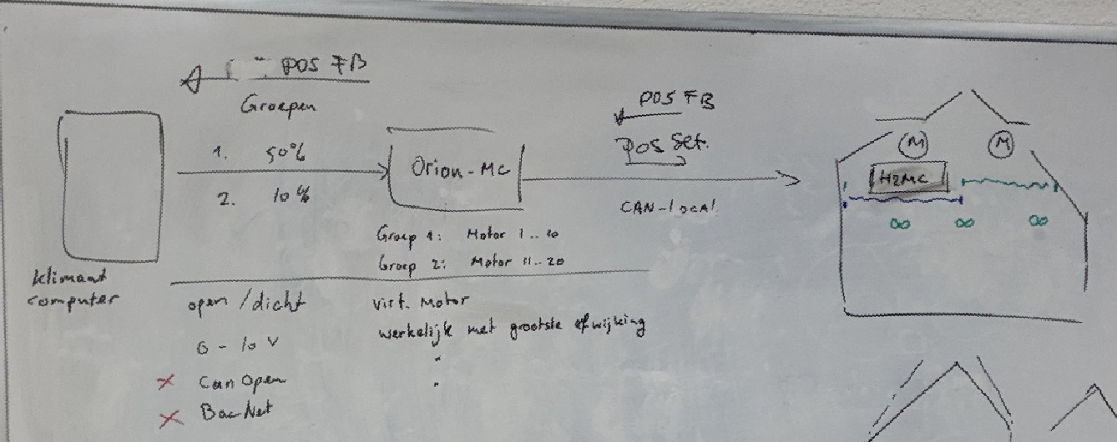
- Climate computer (priva, hoogendoorn)
Gives an assignment, for example: "group 1 to 50%".
- Orion MC
Behaves in front of the climate computer as one virtual motor per group. Orion translates the group assignment into individual motorcycle assignments.
- H1MC / H2MC Motor Controllers
Control the motors in the field, read encoders, determine the motor position and return status, position and alarms via CAN Local. H1MC: Single-motor controller, H2MC: controller for two motors.
  - Motors and encoders
The encoders provide pulses that allow the motor controller to determine position, running time and any deviations.

Motor groups
An motor group contains several motors, for example all motors on a window side. The climate computer only knows the group and does not need to know which individual motor controllers and motors are underneath.
Orion MC:
- receives the desired group position;
- controls all paired motor controllers;
- monitors the actual positions for alarms;
- handles feedback and alarm situations.
Control methods
Historically, several interfaces have been possible:
- open/close contacts;
- 0–10 V Volt
- CANopen;
- BACnet.
The following are particularly relevant to this project:
- open/close control
- 0–10 Volt control
CANopen and BACnet are out of scope.

Open/close control
With open/close control, the climate computer only gives a direction: open, close or do nothing. Orion MC has to give back a position feedback as if the group were one motor. This is done per group.
That's why Orion simulates a virtual motor:
- during installation, motors are calibrated from fully closed to fully open;
- the running time is determined for each motor controller;
- Orion uses the longest duration within the group for the virtual feedback;
- during opening/closing, the virtual position increases or decreases, for example from 0% to 100%;
- As a result, the climate computer sees one consistent motor position and can stop the open or close signal based on this;
- Orion then lets the individual motor controllers control all the motors to the exact desired position.
The actual motor positions are monitored by Orion. When a motor does not reach its target, for example gets stuck at 40% while 50% is requested, Orion can generate an alarm. It is possible that this deviation is also deliberately fed back so that the climate computer can also raise the alarm; This has yet to be verified.

0-10 V control
A 0-10 V signal is given from the climate controller to the Orion MC. The desired position is immediately known, e.g. 5 V = 50%.
The feedback position is based on the motor with the greatest deviation from the target position. This prevents a faulty or lagging motor from being hidden by an average value. For example, the climate computer can signal that the group does not reach the requested position.

Windows, screens and canvases
Functionally, the basis is the same: an motor group brings something to a position. This can be a window, screen, cloth or later also a fan.
The following usually applies to windows:
- 0% = closed;
- 100% = open.
With screens/cloths this is often the other way around:
- 0% = open;
- 100% = closed.
This inversion is part of the motor group's configuration. More complex screen functions, such as linked energy screens and blackout cloths on a two-wire bed, will be covered later.
Convertible greenhouses also require additional logic: certain windows must first move partially before other windows can open or close further. This remains outside the first scope.
Operating Modes and Configuration
At the motor and motor group level, the modes are:
- From: position 0%.
- Automatic: the group follows the command of the climate computer.
- Manual: user sets a desired position himself.
The user interface/configuration must support, among other things:
- number of motor groups;
- motors per group;
- coupling of motors to I/O or CAN Local controllers;
- type of motor group, such as window or screen/cloth;
- manual or automatic operation.
Capacity
Indicative are a maximum of approximately:
- 32 groups;
- 128 motors in total.
In practice, the CAN Local capacity is often rather restrictive. The exact limits are yet to be confirmed.

